Adaptive Multi-Agent Orchestration with Fingerprint-Based Selective Re-execution for LLM Workflows
J A L Dhiraj  UG Student  Computer Science and Engineering  Velammal College of Engineering and Technology.  Madurai, India.  dhirajeng53@gmail.com | N Nithersan  UG Student  Computer Science and Engineering  Velammal College of Engineering and Technology.  Madurai, India.  nithersan3@gmail.com | S Sahebzathi  Assistant Professor  Computer Science and Engineering  Velammal College of Engineering and Technology.  Madurai, India.  [supervisor email]

Abstract — Multi-agent frameworks built on large language models execute a task as a fixed pipeline, so a single mid-execution requirement change forces the whole workflow to restart. Work that the change never invalidated is recomputed, wasting execution time and LLM tokens. Existing systems repair after a step fails, but none decides what remains valid when the requirement itself changes and nothing has failed. This paper proposes an adaptive, capability-aware orchestrator that models a task as a directed acyclic graph and re-executes only the genuinely affected subgraph. Each step is fingerprinted by hashing its own definition together with the exact outputs of its dependencies; a step is re-executed only if it is forced, has no cached result, or its fingerprint no longer matches. Change therefore propagates without an explicit impact rule and terminates as soon as a re-run reproduces identical output. The orchestrator additionally routes tools by capability with fallback chains that end in an always-available local tool, and gates irreversible actions behind human approval at no additional token cost. Evaluated over seven scenarios against a restart-all baseline and a LangGraph implementation performing identical agent work, the proposed system reduced step executions by 24% (54 versus 71) and token consumption by 22% (19,196 versus 24,502), reaching 40% on leaf-change and no-op re-run scenarios. An ablation replacing output fingerprints with downstream-cone invalidation confirms that hashing outputs, not dependency identities, is what terminates propagation. The prototype comprises 610+ automated tests at approximately 90% coverage and integrates live Model Context Protocol servers.
Keywords— Multi-Agent Systems, Large Language Models, Workflow Orchestration, Directed Acyclic Graph, Selective Re-execution, Incremental Computation, Tool Fallback, Model Context Protocol.
I. Introduction
Large language models are increasingly deployed not as single assistants but as coordinated teams of agents that plan, write code, call external services and verify each other's output. Frameworks such as AutoGen [2], MetaGPT [3] and LangGraph [10] have made such systems practical, and they are now applied to software construction, data analysis and enterprise automation. Otoum and Elkhalili [8] document the rapid growth of this area and the convergence of these systems on a common execution model.
That common model rests on a structural assumption: the workflow is fixed once planning ends. A task is decomposed into stages that execute in order, and the only recognised failure mode is a step that errors. Real projects violate this assumption constantly. A requirement changes mid-execution — a stakeholder asks for PostgreSQL instead of MongoDB — and no step has failed at all. Every stage completed successfully, yet some outputs are now stale while others remain perfectly valid.
Current systems handle this by restarting. The full pipeline re-runs, recomputing stages the change never touched. Because each re-executed stage issues fresh model calls, the waste is measured in tokens as well as in wall time, and it scales linearly with workflow size. In the measurements reported in Section V, a database change midway through a five-step build caused both baseline systems to execute ten steps where six sufficed.
The underlying deficiency is analytical rather than architectural. Determining which steps a requirement change invalidates is a question about the relationship between a step's inputs and its cached output, and no published orchestration framework maintains the information needed to answer it. The problem is closely related to incremental computation in build systems, but differs in an important respect: an agent step's output is a natural-language artefact whose equality cannot be assumed from its inputs alone, so invalidation must be observed rather than predicted.
The contributions of this paper are:
- Fingerprint-based change propagation. A step's hash covers its own definition and its dependencies' exact outputs, so invalidation propagates implicitly and halts when a re-run reproduces identical output — behaviour that static dependency analysis cannot express, as the ablation in Section V-D demonstrates.
- Capability-equivalent tool fallback. Tools are grouped by capability into chains terminating in an always-available local tool, allowing a workflow to complete with every remote service unavailable.
- Planner-generated specialist agents. Roles are synthesised per task rather than selected from a fixed roster.
- Pre-execution requirements analysis. Required credentials, servers and binaries are reported, and feasibility decided, before any token is spent.
- Zero-cost approval of irreversible actions. The generated payload is retained across the approval pause, so human sign-off does not re-invoke the model.
The remainder of this paper is organised as follows. Section II surveys existing multi-agent and tool-using systems and identifies the research gap. Section III describes the system architecture. Section IV presents the orchestration method, including the fingerprint definition and re-execution rule. Section V reports experimental results across seven scenarios together with an ablation study. Sections VI and VII discuss future work and conclude.
II. Literature Survey
A. Multi-Agent LLM Frameworks
AutoGen [2] frames collaboration as conversation between configurable agents that exchange messages until a task is judged complete. The paradigm is general and has been widely adopted, but coordination is carried in dialogue rather than in an explicit dependency structure. Two consequences follow: conversational loops consume tokens proportional to the length of the exchange rather than to the work performed, and there is no structural representation over which selective re-execution could be defined.
MetaGPT [3] encodes standard operating procedures drawn from software engineering practice, assigning roles such as product manager, architect and engineer along an assembly line with defined handoffs. The division of labour measurably improves output quality on code generation benchmarks. However, the pipeline is fixed at design time; a requirement change re-enters at the top of the line, and the roles available are those the framework authors anticipated.
HuggingGPT [7] uses a language model as a controller that plans a task, selects expert models from a public repository, and sequences their invocation. Planning is genuinely dynamic and tool selection is open-ended. The plan is nonetheless discarded once execution ends, so no prior result is carried forward when a related or repeated request arrives.
B. Single-Agent Reasoning and Tool Use
ReAct [4] interleaves reasoning traces with tool actions, allowing a model to ground its reasoning in retrieved evidence. It improves factuality within a single agent, but the trace is linear and single-threaded, and the method offers no orchestration across steps and no recovery when an action fails.
Reflexion [5] adds verbal self-reflection: a failed attempt is analysed in natural language and retried with an improved strategy, which raises success rates on multi-attempt tasks. The retry is confined to the failing step. Reflexion can reason about why one step failed but not about which other steps that failure, or a change, renders invalid.
Toolformer [6] teaches a model when and how to invoke an API through self-supervision, removing the need for hand-written tool-use prompts. The binding between task and tool is fixed at inference time; when a tool is unavailable the call simply fails, and no capability-equivalent alternative is attempted.
C. Workflow-Oriented Orchestration
Closest to the present work, Deng et al. [1] model multi-agent AutoML execution explicitly as a directed acyclic graph. A workflow orchestrator parses the requirement, constructs or retrieves the task graph, and dynamically assigns executable subtasks to specialised agents. Each subagent verifies input availability, capability–task matching and constraint compliance before executing, returning structured diagnostic feedback when a failure occurs. The orchestrator aggregates intermediate results, evaluates the workflow using a global acceptance score, and performs targeted replanning through a closed-loop repair mechanism. The present work adopts this graph model and its capability-matching idea, and extends it with a criterion for reuse.
Otoum and Elkhalili [8] survey agentic software engineering systematically and report the same pattern across the field: robustness research concentrates on detecting and recovering from failure, while the question of what remains valid after a specification change is largely unaddressed.
D. Comparative Summary
TABLE I: Capability Comparison of Related Systems
System | Multi-agent | Explicit graph | Reuse on change | Tool fallback
AutoGen [2] | Yes | No | No | No
MetaGPT [3] | Yes | Fixed SOP | No | No
ReAct [4] | No | No | No | No
Reflexion [5] | No | No | No | No
Toolformer [6] | No | No | No | No
HuggingGPT [7] | Yes | Per-run plan | No | No
Deng et al. [1] | Yes | Yes (DAG) | No | Verify only
Proposed | Yes | Yes (DAG) | Yes | Yes

E. Research Gap
As Table I summarises, adaptation across this literature is triggered by failure. A step errors, and the system diagnoses, retries or replans. The case in which nothing fails and the requirement changes instead is not addressed by any of the surveyed systems. In that case the workflow holds a mixture of stale and still-valid results, and no published mechanism distinguishes between them; adaptation consequently degenerates into restarting, discarding valid work. Three further gaps follow from the same fixed-pipeline assumption: tool bindings are static, so an unavailable tool halts execution; results are not reused across runs of related tasks; and irreversible actions such as sending mail or applying a migration execute without a human checkpoint. This paper addresses these within a single orchestration algorithm.
III. System Architecture
The orchestrator is organised in three layers. A control layer accepts the task and owns the workflow lifecycle. A coordination layer comprising the Task Planner, Workflow Engine and Memory Manager decides what runs and in what order. An execution layer comprising the Agent Manager and Tool Manager performs the work. Cross-cutting services — persistence, an event bus, a requirements checker, the approval gate and a dashboard — sit beneath all three. Fig. 1 illustrates the arrangement.
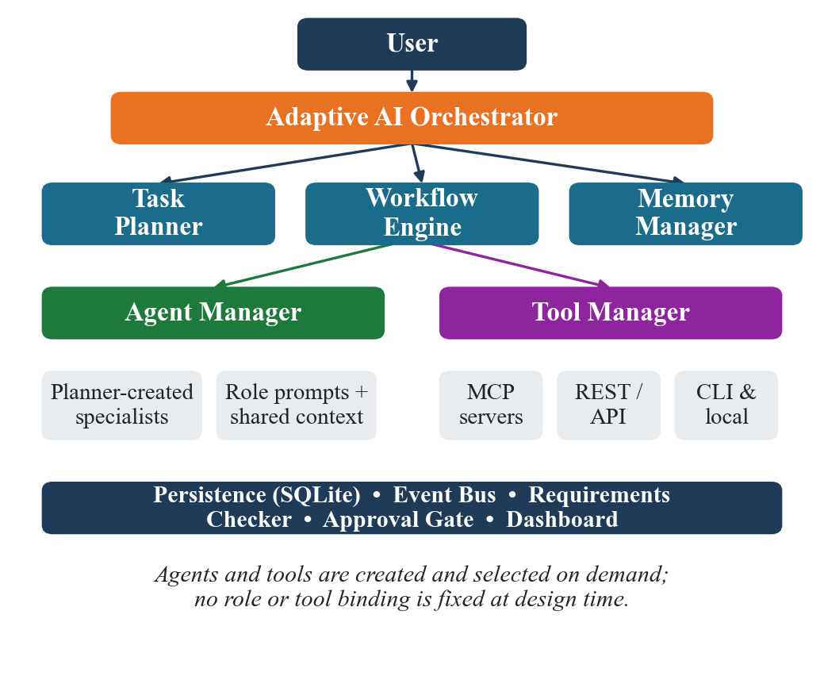
Fig. 1. Layered architecture of the proposed orchestrator.
A. Task Planner
The planner receives a plain-English task and emits a set of steps, each with a description, an assigned role, a required capability and a dependency list. It additionally synthesises the specialist roles the task requires. Because roles are generated rather than selected, a clinical task may produce a trial-statistician role and a legal task an employment-lawyer role without any change to the framework. The emitted plan is validated as a directed acyclic graph before execution; a plan containing a cycle or a dangling dependency is rejected whole rather than partially applied.
B. Agent Manager
The Agent Manager instantiates one agent per planner-declared role, each with a role-specific system prompt and access to a shared context of upstream outputs. Agents are created on demand and retired when the workflow completes, so the active set matches the task rather than a predefined roster.
C. Tool Manager
Tools register against capabilities rather than being named directly by steps. The manager maintains, for each capability, an ordered chain of providers and selects the first that is live. Providers are reached through the Model Context Protocol [9] over stdio, SSE or streamable-HTTP transports, through authenticated REST connections supporting bearer, basic, API-key and OAuth2 client-credentials schemes, or through local command-line tools.
D. Memory, Persistence and Observability
Every step result is persisted to an embedded SQLite database together with the fingerprint under which it was produced. This record is what makes reuse possible across runs and what allows an interrupted workflow to resume. An event bus publishes state transitions as they occur; a web dashboard subscribes over WebSocket and renders the dependency graph live, marking each step as reused or re-executed.
IV. Methodology
A. Dependency Graph and Execution Levels
Steps are topologically ordered. Steps that share no ancestor are grouped into execution levels and dispatched in parallel across a worker pool, so independent branches do not serialise. Level construction is performed once per plan and reused across re-runs, since the graph shape changes only when the plan itself is edited.
B. Input Fingerprinting
Let s be a step, D(s) its definition — description, assigned role, required capability and declared inputs — and dep(s) = (d1, ..., dk) the ordered set of steps on which s depends. Let O(d) be the output produced by dependency d. The fingerprint of s is given by equation (1):
F(s) = H( D(s) || O(d1) || O(d2) || ... || O(dk) ) (1)
where H is a cryptographic hash function and || denotes ordered concatenation. The essential property is that F(s) closes over dependency outputs rather than dependency identities. It therefore records not merely that a predecessor exists, but exactly what that predecessor produced on the run whose result is cached.
C. Selective Re-execution
A step is executed if and only if the condition in equation (2) holds:
run(s) <=> forced(s) OR cached(s) = NULL
OR F(s) != F_prev(s) (2)
Two properties follow. First, change propagates automatically. Modifying a step alters its output, which alters the fingerprint of every step depending on it, which re-executes in turn, and so on transitively. No explicit impact rule is written or maintained, and none can fall out of date as the graph evolves.
Second, propagation is self-limiting. If a re-executed step reproduces byte-identical output, the fingerprints of its dependents are unchanged and the cascade stops there. A change is thus confined to the subgraph it genuinely affects, which may be strictly smaller than its transitive dependency cone. Fig. 2 illustrates the mechanism on a linear chain: an edit to A propagates through B and C, but because C reproduces its previous output, D's fingerprint is unchanged and the cascade halts before reaching it. This distinction is not merely theoretical; Section V-D measures it.
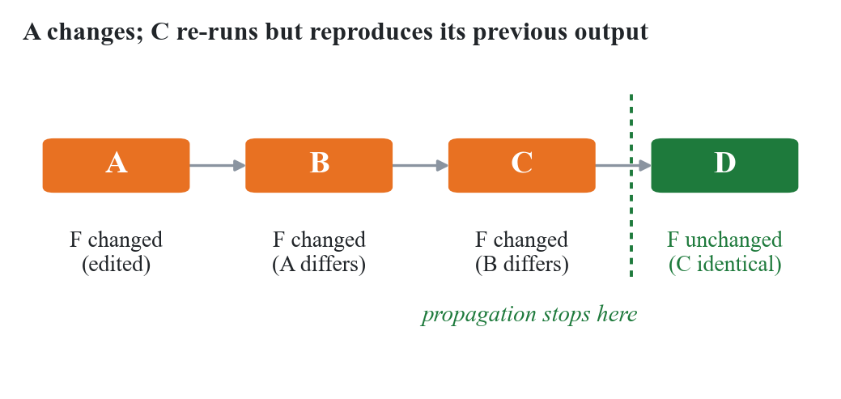
Fig. 2. Fingerprint propagation terminating at an unchanged output.
D. Worked Example
Consider a five-step build: requirements analysis, frontend, backend, database schema and integration testing, where testing depends on all three implementation steps and those depend on requirements. Suppose the client switches the database from MongoDB to PostgreSQL after a complete run.
The database step's definition D(s) changes, so F(database) changes and the step re-executes. Its new output differs, so F(testing), which closes over the database output, also changes and testing re-executes. The frontend and backend steps depend only on requirements, whose definition and output are unchanged; their fingerprints match and their cached results are returned without a model call. Four of five steps are examined and two are executed. Had the requirements step changed instead, every downstream fingerprint would change and all five would execute — correctly, since all five would then be stale. Fig. 3 shows the resulting partition of the graph.
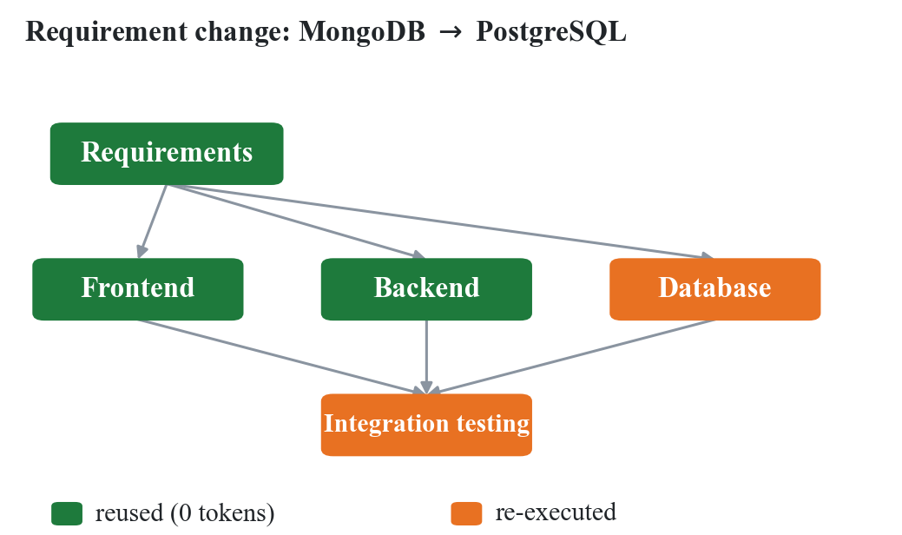
Fig. 3. Selective re-execution after a database requirement change.
E. Capability-Based Tool Routing
When a step is executed, the Tool Manager resolves its declared capability to a concrete provider. If that provider raises an error or is unreachable, the next provider in the capability's chain is attempted transparently, and the step is not marked failed while alternatives remain. Every chain terminates in a local tool requiring no network access, which guarantees that a workflow can complete even under total remote-service failure, albeit with reduced fidelity. Substitution is recorded in the run log so that the degraded path is visible afterwards.
F. Human-in-the-Loop Gate
Tools declare whether a given invocation is irreversible — sending mail, pushing a commit, applying a migration. When such a call is reached, execution pauses and the exact payload that would be transmitted is presented for approval. The payload is retained across the pause, so approval resumes execution without re-invoking the model. Approval is therefore free in token terms, which removes the practical incentive to disable the checkpoint that exists in systems where confirming an action means regenerating it.
G. Orchestration Algorithm
Input : task T, prior run state R (may be empty)
Output: completed workflow W
1: G <- Plan(T) // validated DAG
2: A <- SynthesiseAgents(G)
3: If not RequirementsMet(G): report; halt
4: For each level L in TopoLevels(G) do
5: For each step s in L in parallel do
6: F <- Hash(D(s), Outputs(dep(s)))
7: If forced(s) or R[s]=NULL or F != R[s].F:
8: t <- SelectTool(capability(s))
9: If irreversible(t,s): AwaitApproval(s)
10: O <- Execute(s, t, A[role(s)])
11: If failed: t2 <- Fallback(capability(s));
12: O <- Execute(s, t2, A[role(s)])
13: R[s] <- (F, O)
14: Else: O <- R[s].O // reuse, 0 tokens
15: Return W from R
H. Complexity
For a graph of n steps and e dependency edges, topological ordering and level assignment are O(n + e). Fingerprint computation hashes each step's definition once and each dependency output once, giving O(n + e) hash input overall. The scheduling overhead is therefore linear in graph size and independent of the cost of the steps themselves, which is dominated by model inference. Because a single avoided step saves an entire model call, the overhead is negligible relative to the saving whenever any reuse occurs.
V. Results and Discussion
A. Experimental Setup
The system was evaluated against three comparison systems. The first is a restart-all policy that re-runs the entire workflow on any change. The second is an equivalent implementation in LangGraph [10]. The third is an ablation of the proposed system in which output fingerprints are replaced by downstream-cone invalidation: when a step changes, its entire transitive dependency cone is marked dirty, which is what conventional dependency analysis prescribes. All four perform identical agent work and use a deterministic offline language model with a fixed 0.05 s simulated call latency, so measured differences arise from the scheduling policy alone. Step, call and token counts are exact and reproducible; wall-clock figures are the median of three repetitions and remain machine-dependent.
Seven scenarios were used, defined in Table II, spanning a cold run, changes at three different graph depths, a re-run producing identical output, a mid-workflow tool outage, and a larger eight-step graph.
TABLE II: Benchmark Scenario Definitions
Scenario | Description
full_run | Cold start; execute all five steps once
early_change | Requirement changes at the root, invalidating almost everything
mid_change | Client switches database mid-project (the classic case)
leaf_change | Change at a leaf; nothing downstream depends on it
noop_rerun | A mid-graph step re-runs but produces an identical result
tool_failure | The GitHub API becomes unavailable mid-workflow
microservices_change | Eight-step microservices build; one service's requirements change

B. Per-Scenario Results
Fig. 4 reports step executions. In full_run and early_change all four systems coincide: on a cold start nothing is cached, and when the root changes every downstream fingerprint changes, so the whole graph is genuinely invalid. Saving nothing in early_change is the correct outcome, not a shortfall — reuse there would return stale results. Divergence appears from mid_change onward, growing as the change moves further from the root.
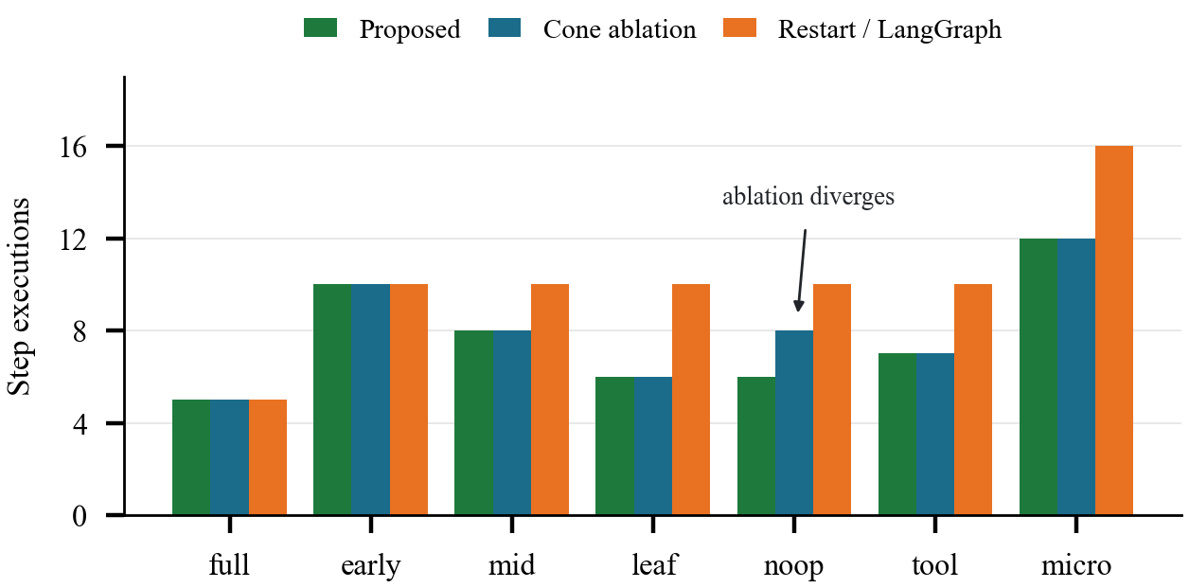
Fig. 4. Step executions per scenario across the four systems.
C. Aggregate Results
TABLE III: Aggregate Results Across Seven Scenarios
Metric | Proposed | Cone | Restart | LangG.
Step executions | 54 | 56 | 71 | 71
Tokens consumed | 19,196 | 20,016 | 24,502 | 24,502
Wall time (s) | 2.76 | 2.90 | 4.46 | 3.37
vs proposed (steps) | — | +4% | +24% | +24%
vs proposed (tokens) | — | +4% | +22% | +22%

Aggregated over the seven scenarios the proposed scheduler performed 54 step executions against 71 for both external baselines, a 24% reduction, and consumed 19,196 tokens against 24,502, a 22% reduction. Wall time fell by 38% against restart-all and 18% against LangGraph, though the latter figures reflect the simulated call latency and should be read as indicative. The two external baselines coincide exactly because LangGraph, lacking any reuse criterion, re-executes the same node set as an explicit restart; its advantage over restart-all is in scheduling efficiency rather than in avoided work.
D. Ablation: Fingerprints versus Dependency Cones
The third comparison system isolates the paper's central claim. It retains the DAG, the parallel level scheduling and the caching layer, and differs only in the invalidation rule: instead of comparing output fingerprints it marks the whole transitive cone of a changed step dirty.
Across six of seven scenarios the two are identical. The entire difference appears in noop_rerun, where the cone variant executes eight steps against the proposed system's six. The reason is precisely the termination property of Section IV-C: when the re-run step reproduces its previous output, dependent fingerprints are unchanged and propagation halts, whereas cone invalidation has already marked those dependents dirty on structural grounds and cannot un-mark them. Aggregate cost rises by 4% in both steps and tokens.
The margin is modest in these seven scenarios because only one exercises the case. Its practical weight depends on how often re-execution is idempotent, which in agent workflows includes retried flaky steps, edits that prove cosmetic, and re-runs after an unrelated part of the graph changes. The result establishes the mechanism rather than its frequency: hashing outputs strictly dominates hashing dependency structure, and never performs worse.
E. Sensitivity to Change Position
The aggregate figure conceals a systematic dependency on where a change lands, reported here explicitly because it bounds the method's usefulness. In early_change, a root modification invalidates the whole graph and the saving is zero. In mid_change the saving is 20% of steps; in leaf_change and noop_rerun it reaches 40%. The 24% aggregate is therefore a midpoint of a 0–40% range determined by graph topology and change position, and the method is best understood as one that eliminates provably unnecessary work rather than one offering a uniform speedup. Its value grows with graph depth and with the lateness of typical changes, both of which increase in larger projects — the eight-step microservices scenario, the largest tested, saved 25% of steps.
F. Tool-Failure Recovery
In tool_failure the GitHub API becomes unavailable partway through the workflow. The baselines record a failed step requiring manual intervention. The proposed system resolves the affected capability to the next provider in its chain and continues, completing in seven steps against ten. The substitution is logged, so the degraded execution path is visible in the run record rather than silently absorbed.
G. Implementation and Validation
The prototype comprises the planner, dependency graph, agent manager, tool manager, memory, SQLite persistence and event bus, validated by 610+ automated tests at approximately 90% statement coverage. It connects to live Model Context Protocol servers over stdio, SSE and HTTP; a Playwright server contributes 24 browser tools to the agent pool. Real integrations include GitHub REST, PostgreSQL, SMTP mail and authenticated API connections. An end-to-end demonstration opens a live web page in a real browser, extracts content, drafts a message and delivers it by SMTP, pausing for approval before sending. The system supports six model providers behind a common interface, including a deterministic offline provider used for the measurements reported here.
H. Threats to Validity
The evaluation uses a deterministic offline model to isolate scheduling effects. With a stochastic model, a re-executed step may produce differing output for identical inputs, which would weaken the termination property of Section IV-C and narrow the margin measured in the ablation; addressing this is the subject of the semantic-fingerprinting proposal in Section VI. The seven scenarios are synthetic and modelled on software construction workflows, so savings on other task families may differ. Wall-clock figures incorporate a simulated call latency and should not be read as production throughput. Finally, comparison against AutoGen and CrewAI has not been performed and no claim is made regarding them.
VI. Future Work
Four directions follow from the limitations above. First, extending the benchmark to AutoGen and CrewAI would situate these results against the two most widely adopted frameworks; the harness is baseline-agnostic and this is principally an implementation exercise.
Second, semantic fingerprinting — treating two outputs as equivalent when they differ textually but agree in meaning, for example through embedding similarity above a threshold — would extend reuse to stochastic models, where exact-match hashing is brittle. This introduces a correctness risk that exact hashing does not carry, and would require an empirical study of the threshold–staleness trade-off.
Third, persisting fingerprints across sessions and tasks would allow reuse between related workflows rather than only within successive runs of one, turning the memory layer into a cross-task cache. Fourth, a cost model weighing the expense of re-execution against the risk of reusing a marginally stale result would let the scheduler make an explicit trade-off where the present rule is strictly conservative — always re-executing when in doubt.
VII. Conclusion
This paper presented an adaptive multi-agent orchestrator that re-executes only the part of a workflow a change genuinely invalidates. By fingerprinting each step over its own definition and the exact outputs of its dependencies, invalidation propagates without an explicit impact rule and terminates as soon as a re-run reproduces identical output. The orchestrator further routes tools by capability with fallback chains ending in an always-available local tool, and gates irreversible actions behind an approval step that costs no additional tokens.
Measured across seven scenarios against a restart-all baseline and a LangGraph implementation performing identical work, the approach reduced step executions by 24% and token consumption by 22%, rising to 40% where a change lands late in the graph and falling to zero where a change invalidates everything — the correct outcome in that case. An ablation replacing output fingerprints with conventional downstream-cone invalidation cost 4% more steps and tokens, confirming that hashing outputs rather than dependency structure is what allows propagation to terminate. The prototype is validated by 610+ automated tests and integrates live MCP servers and real external services.
The wider observation is that existing agent frameworks treat adaptation as recovery from failure, whereas the more common event in practice is a requirement that changes while nothing has failed. Distinguishing stale results from valid ones is what that case requires, and it is a question about outputs rather than about structure.
References
[1] L. Deng, J. Yan, C. Cao, M. Zhao and S. Jin, “Dynamic Workflow Orchestration with Executability Verification for Multi-Agent AutoML Task Execution,” in 2026 6th Int. Conf. on Artificial Intelligence, Big Data and Algorithms (CAIBDA), IEEE, 2026, doi: 10.1109/CAIBDA70336.2026.11621590.
[2] Q. Wu et al., “AutoGen: Enabling Next-Gen LLM Applications via Multi-Agent Conversation Framework,” arXiv:2308.08155, 2023.
[3] S. Hong et al., “MetaGPT: Meta Programming for a Multi-Agent Collaborative Framework,” arXiv:2308.00352, 2023.
[4] S. Yao et al., “ReAct: Synergizing Reasoning and Acting in Language Models,” arXiv:2210.03629, 2022.
[5] N. Shinn et al., “Reflexion: Language Agents with Verbal Reinforcement Learning,” arXiv:2303.11366, 2023.
[6] T. Schick et al., “Toolformer: Language Models Can Teach Themselves to Use Tools,” arXiv:2302.04761, 2023.
[7] Y. Shen et al., “HuggingGPT: Solving AI Tasks with ChatGPT and its Friends in Hugging Face,” arXiv:2303.17580, 2023.
[8] N. Otoum and N. Elkhalili, “Methods and Techniques of Agentic Software Engineering: A Systematic Literature Review,” IEEE Access, 2026, doi: 10.1109/ACCESS.2026.3652325.
[9] Anthropic, “Model Context Protocol Specification,” 2024. [Online]. Available: modelcontextprotocol.io
[10] LangChain, “LangGraph Documentation,” 2024. [Online]. Available: langchain-ai.github.io/langgraph

